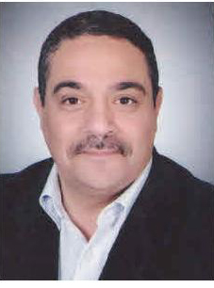

Profile
Bachelor: basic vet medical science 1986 graduates first
Work as demonstrator in dept of microbiology and immunology 1987
Master degree in immunology 1991
Work as assistant lecturer in dept of microbiology and
Immunology 1991
Ph D degree in immunology 1994
Work as lecturer Immunology 1994
Assistant professor in immunology 2004
Professor in immunology 2011

